YOUR VMA LOGO HERE

7 Key Ingredients for Maximizing Client Loyalty

Stacee Santi, DVM

Thursday, May 19, 2022
2:30 PM Eastern/1:30 PM Central/12:30 PM Mountain/11:30 AM Pacific
FREE Webinar for VMA Members
Click here to register today!
In this session, the attendee will learn the 7 levers that strengthen the bond with their clients. Understanding the client’s “love language” is an essential part of building (and keeping) a profitable, sustainable, efficient practice centered around the veterinary-client relationship. Identifying, retaining and engaging customers, especially high and mid-value, is critical to maximizing the veterinary team’s daily impact on the lives of animals.

Learning Objectives
- Recognize the way pet owners value veterinary services
- Identify areas of opportunity to embrace that can strengthen the bond with clients
- Understand how loyalty programs work and their impact on the practice’s financials
- Recognize the personal and team benefits to reducing client churn as it relates to burnout, stress and exhaustion

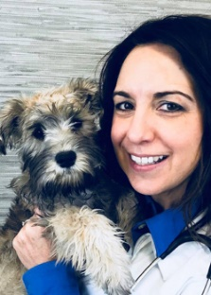
Stacee Santi, DVM
Stacee Santi, DVM, is the founder and CEO of Vet2Pet, the only customizable, all-in-one client engagement and communication platform for veterinary practices. Since earning her DVM from Colorado State University in 1996, Dr. Santi has accumulated more than 20 years of clinical experience in small animal and emergency practice, has spent significant time serving on various industry advisory boards, and served as 2020 president of the Colorado Veterinary Medical Association. Considered a key opinion leader on mobile applications and client loyalty, Dr. Santi is passionate about helping veterinary practices better connect with their clients so pets get the best care and veterinary professionals enjoy more fulfilling, balanced careers. Dr. Santi lives in Durango, Colorado, with her husband, six horses, two dogs, 1 cat, two chickens, seven ducks and hopefully a baby burro one day.

